学术海报制作要求
Academic Poster Production Requirements

1. 请确认海报内容分属于医药学、农业生命环境、人文社科或理工的类别，然后使用主办方设置的类别主题模版，如图1所示。
Please confirm which category your poster belongs to: (1) Medicine and Pharmaceutical Sciences (2) Agriculture, Life and Environment Sciences, (3) Arts, Humanities and Social Sciences or (4) Science and Engineering, then use the theme template set by the organizer, as shown in Figure 1.
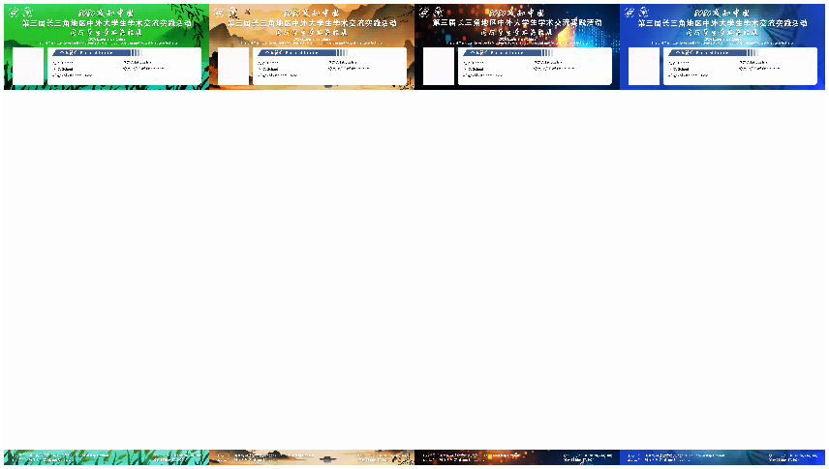
- 医药学类 Medicine and Pharmaceutical Sciences Agriculture
- 农业生命环境类 Life and Environment Sciences
- 人文社科类 Arts and Humanities and Social Sciences
- 理工类 Science and Engineering
图1 主题模版
Figure 1 Theme Template
模版链接：https://pan.quark.cn/s/8dc4e34c06a3
2.海报整体尺寸：180cm*80cm，主体内容展示部分尺寸：140cm*80cm。主体内容部分，版面上下页边距为25mm，左右边距为20mm-50mm，请确保尺寸正确，方便制作及安装，否则将影响您的作品的呈现效果。海报式样参见图2。
Overall poster size: 180cm * 80cm, main content display area size: 140cm * 80cm. The top and bottom margins of the main content area are 25mm, and the left and right margins are 20mm-50mm. Please ensure the correct dimensions for ease of production and installation, as incorrect dimensions will affect the presentation of your work. See Figure 2 for poster style.

3.建议您使用PowerPoint 或者 PS等软件进行设计，将设计好版面的Poster保存为jpg、tif、bmp、pdf等高清格式。
We recommend to use PowerPoint or Photoshop for designing your posters. Please save your poster in jpg, tif, bmp, pdf, or other high-definition formats.

4. 海报命名为“学校名称+类别+学生姓名”，例如“浙江大学+医药学类+XXX”。
The poster should be named as "University name+category+student name", for example, "Zhejiang University+Science and Engineering+XXX".

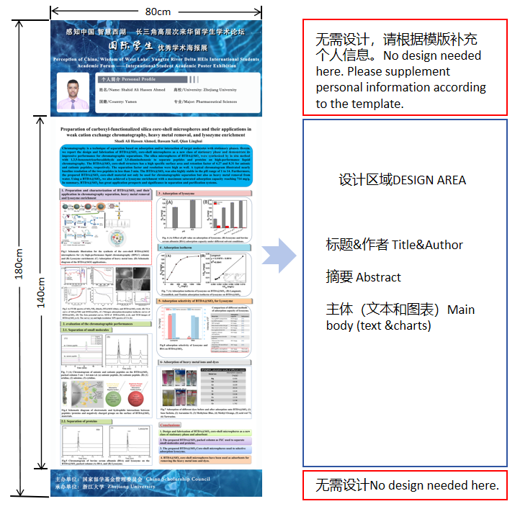
图2 海报式样
Figure 2 Example of poster

操作提示：请调整页面尺寸，并预留页边距
Operation Tip: Please adjust the page size and leave margins.
Setting PowerPoint
- 打开PPT后，点击“设计”按钮；
Open PowerPoint, click on the "Design" .
- 更改“幻灯片大小”；
Modify "Slide Size".
- 改变宽和高80cm*140cm，注意单位为厘米；
Adjust the width and height 80cm*140cm, ensuring the units are in cm.
- 确认 Confirm.
- 页边距请自行调整（尺寸：版面上下页边距为25mm，左右边距为20mm-50mm）
Please adjust the margins as follows: Top and bottom margins: 25mm, Left /Right margin: 20mm-50mm

Setting Photoshop
1.新建一个文件
open a new folder.
2.设置宽度为80cm，高度为140cm
Adjust the width and height 80cm*140cm, confirm.
3.页边距请自行调整（尺寸：版面上下页边距为25mm，左右边距为20mm-50mm）Please adjust the margins as follows: Top and bottom margins: 25mm, Left /Right margin: 20mm-50mm

