【中文版】
中创智领（郑州）工业技术集团股份有限公司（以下称“中创智领”）始建于1958年，前身为郑煤机集团，是全球规模最大的煤矿综采技术和装备供应商、国际领先的汽车零部件制造企业。

- 集团业务：作为A+H股上市公司，中创智领业务涉及煤矿机械、汽车零部件、工业智能、投资等多个业务板块。集团目前拥有31个生产研发销售基地，遍布全球17个国家（包括德国、法国、西班牙、葡萄牙、日本、韩国、泰国、印度、墨西哥等），员工逾16000名。
- 发展历程：2010年在上海证券交易所上市。2012年在香港联合交易所上市。2019年9月，习近平总书记莅临视察，对企业的改革发展和产业转型所取得的成果给予充分肯定。2024年10月8日 郑煤机智慧园区成为全球煤机行业首家灯塔工厂。2025年 公司更名为中创智领集团，向着智能工业发展路径迈进，开启新发展阶段。
- 企业文化：
- 使命：智驱未来，创领美好生活
- 愿景：成为全球领先并可持续发展的智能工业解决方案提供商
- 价值观：面向未来、变革创新、开放协同、追求卓越

欢迎国际人才伙伴加入中创智领，与我们一起开创智能工业解决方案新路径，在前进的道路上互相成就！

【English Version】
ZCZL Industrial Technology Group Co., Ltd (ZCZL Group) is the world’s largest supplier of fully-mechanized coal mining technology and equipment, and an internationally leading manufacturer of automotive components, which was founded in 1958 and formerly known as Zhengzhou Coal Mining Machinery Group (ZMJ Group).
Official website: https://www.zczl.cn/

1. Group Business
As an A+H listed company, ZCZL operates across multiple business segments: coal mining machinery, automotive parts, industrial intelligence, and investment. We have 31 production, R&D, and sales bases spanning 17 countries worldwide (including Germany, France, Spain, Portugal, Japan, South Korea, Thailand, India, Mexico and so on), with a global workforce of over 16,000 employees.

2. Milestones
1) 2010: Listed on the Shanghai Stock Exchange.
2) 2012: Listed on the Hong Kong Stock Exchange.
3) 2019: President of PRC visited and highly commended the Group‘s achievements in reform, development, and industrial transformation.
4) 2024: ZMJ Smart factory became the first Lighthouse Factory in the global coal mining machinery industry.
5) 2025: Renamed ZCZL Group, embarking on a new phase of development toward smart industrial solutions.

3. Corporate Culture
Mission: Intelligence drives a better future.
Vision: With smart industrial solutions, we are the motor for a sustainable world.
Values: Future-focused, Transformation and Innovation, Openness and Collaboration, Pursuit of excellence.

- Why Join Us?
Global Perspective: As a publicly-listed company with a global business footprint, we offer a broad international perspective and a multicultural working environment.
Open and Inclusive Culture: We promote an open and inclusive work culture, respecting the individuality and background of every employee.

- What You Will Gain?
Professional Skill Enhancement: Apply your knowledge to fundamental aspects of enterprise operation, including IT / audit / legal affairs / strategic analysis / risk management / finance / Investment / HR management.
Cross-Cultural Communication: Improve your communication and coordination skills in a diverse and inclusive multinational team.
International Work Experience: Gain valuable cross-cultural work experience through collaboration.

We foster a multicultural workplace that celebrates diversity and welcomes exceptional international job seekers to grow with our global team!

【Company Photos】
- Office buildings and factories
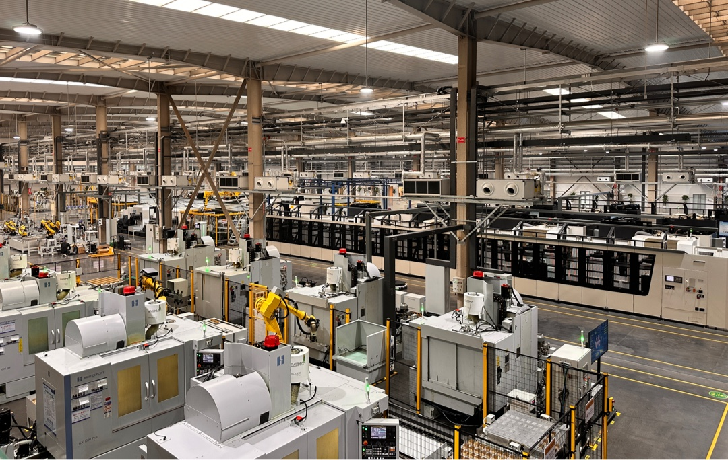
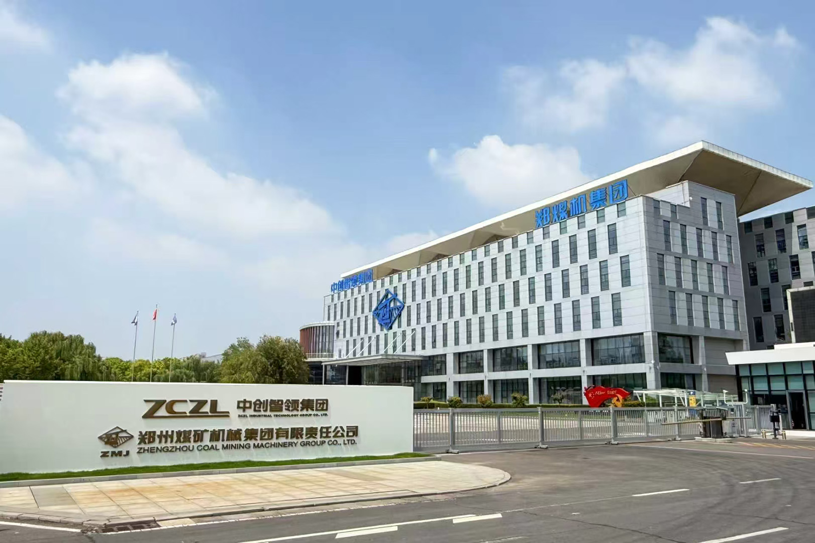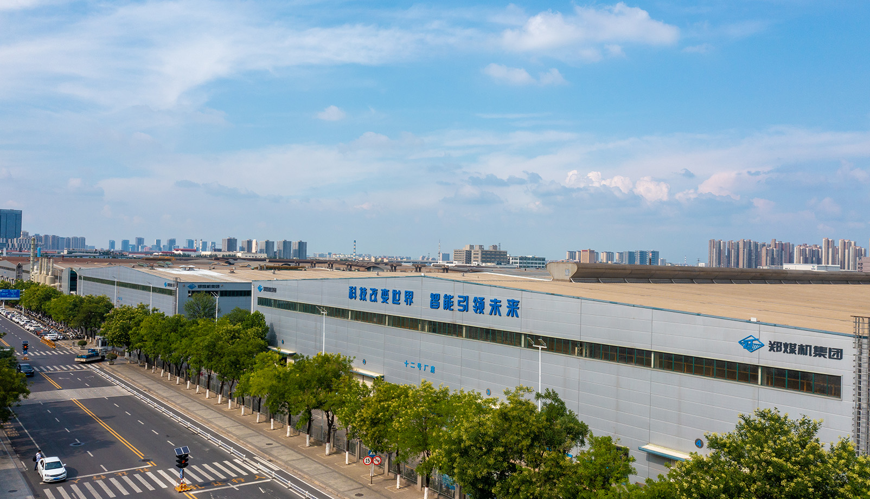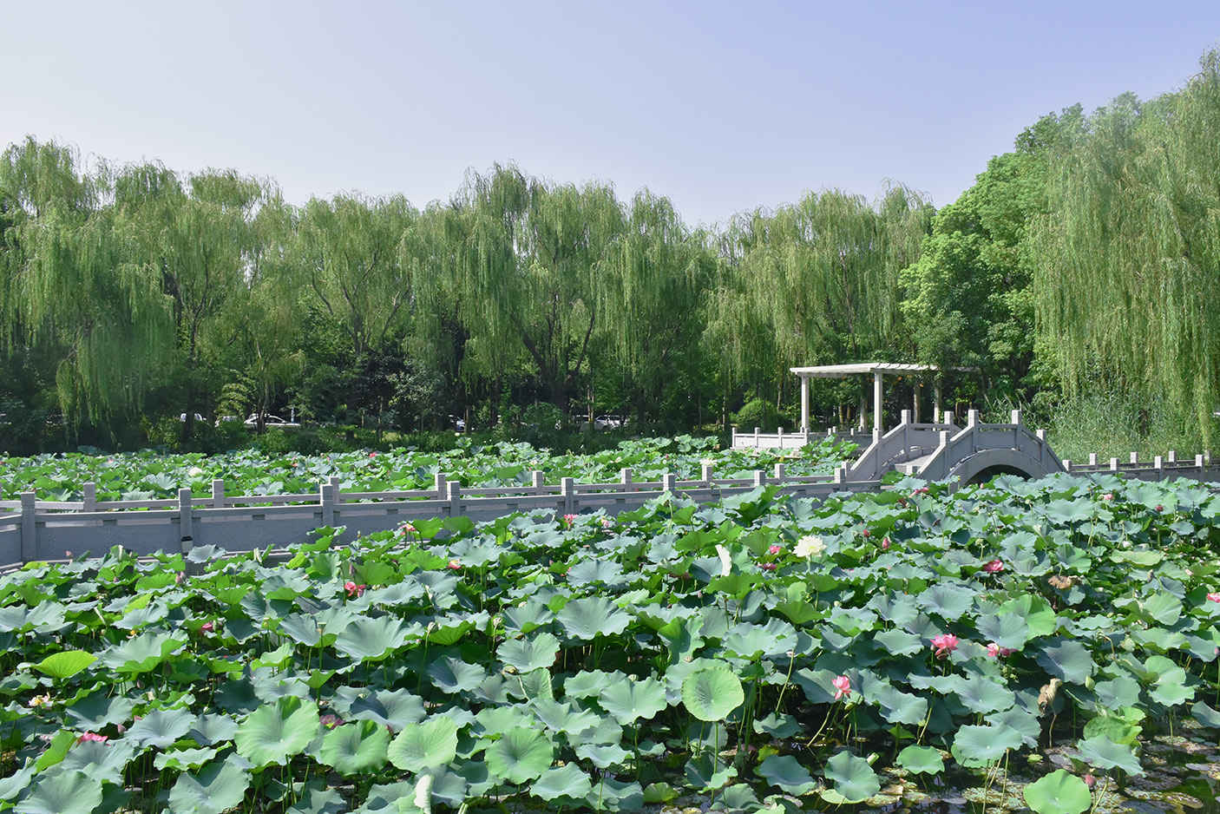
- Free gym for employees
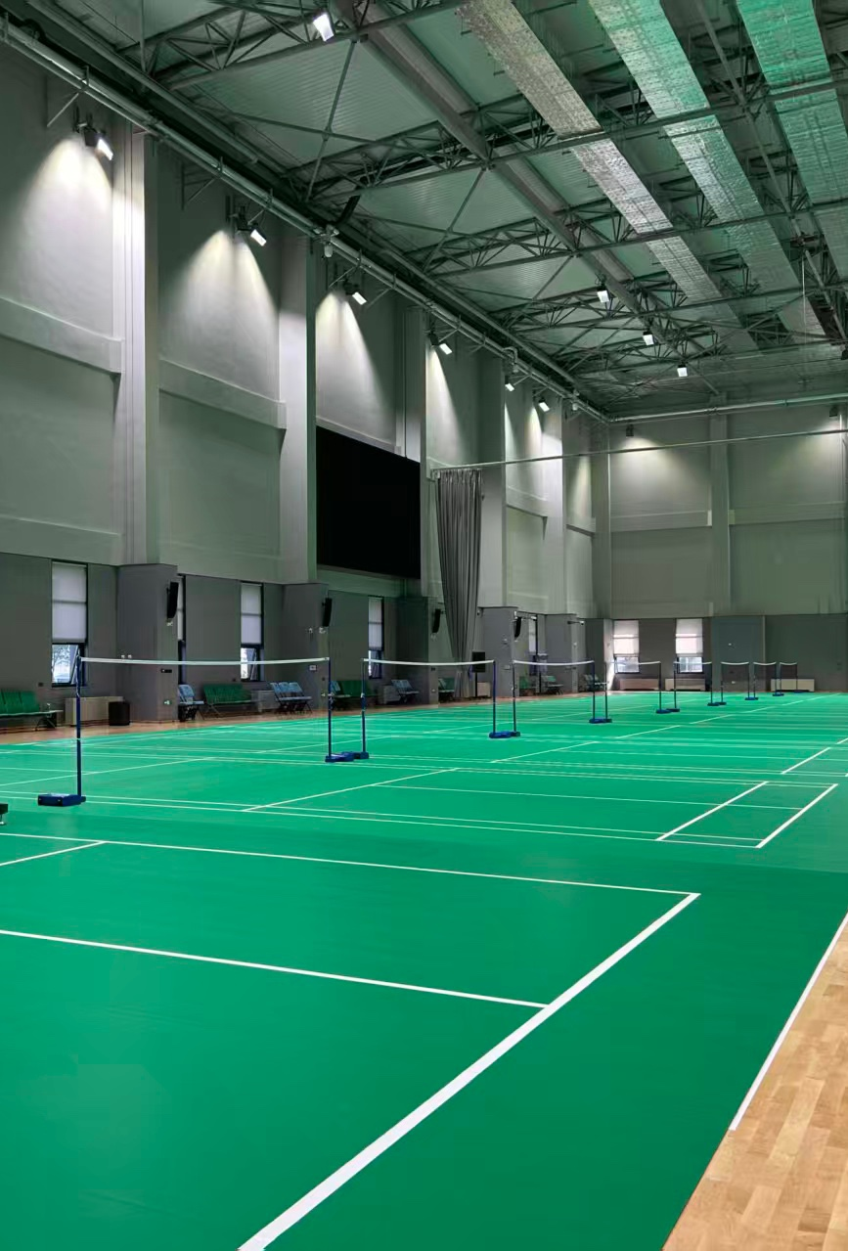
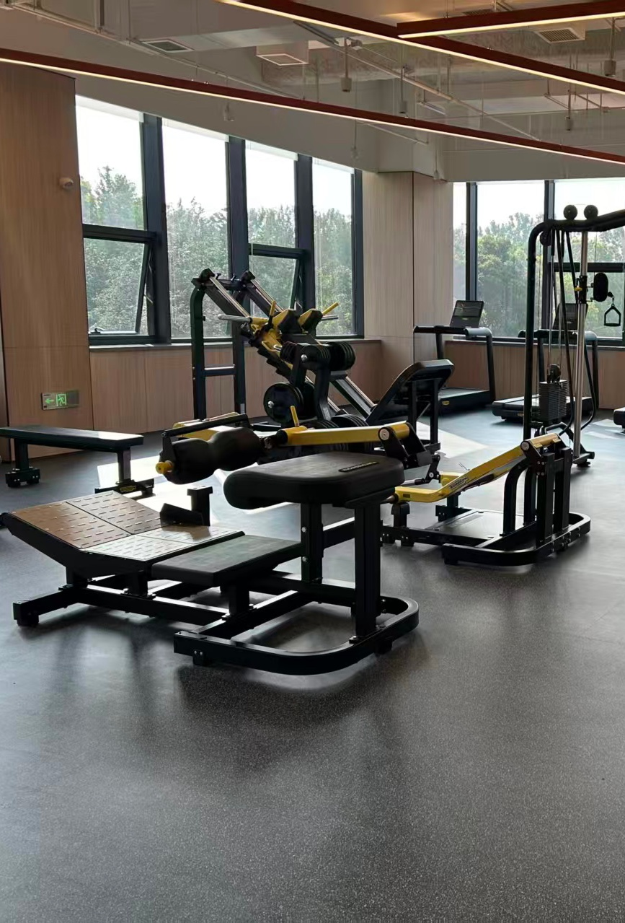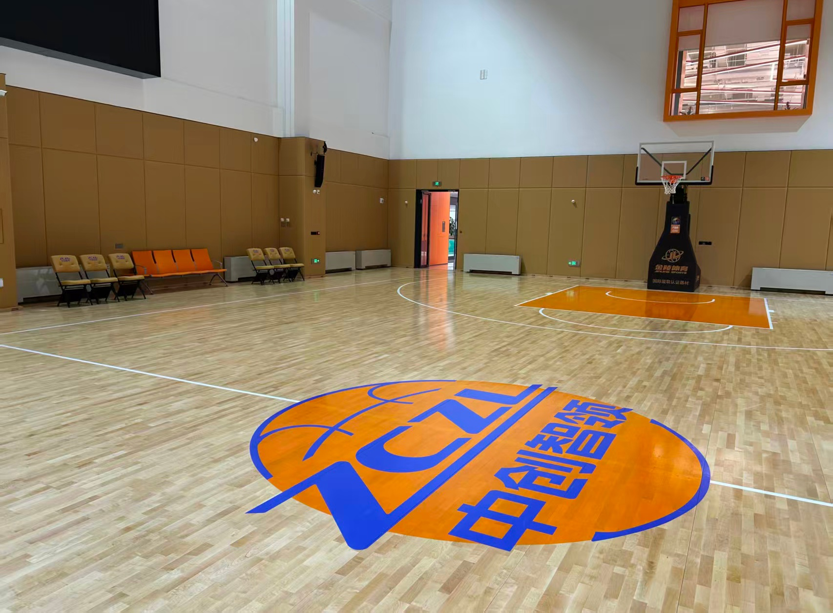
- Office/meeting room
