Instructions for the registration of Postgraduate Students 2020-12-17

- Log into the system entrance.

Log into the Southeast University information portal http://my.seu.edu.cn/, the system uses unified authentication login, user name is a card number, forget the password access https://newids.seu.edu.cn/authserver/getBackPasswordMainPage.do to retrieve the password operation.

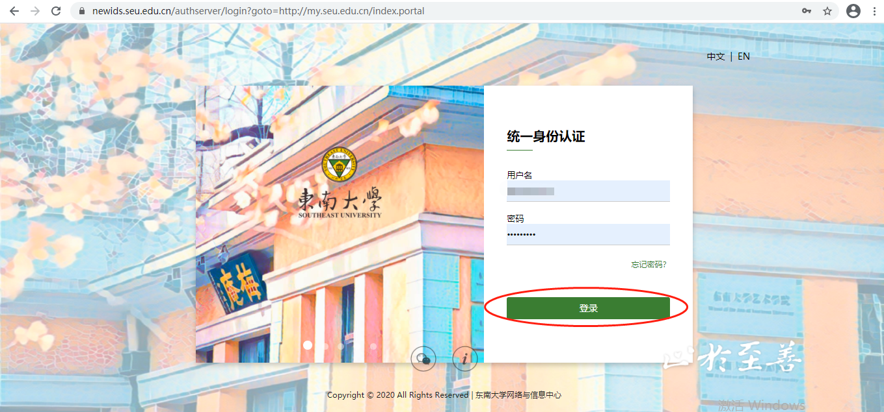

Note: It is recommended to use 360 Extreme Browser Extreme Mode or Google Chrome. If there is an interface that cannot be loaded or information is not displayed in a timely manner, clear the browser cache and log back in.

After logging into the information portal, click on "Integrated Service Hall."

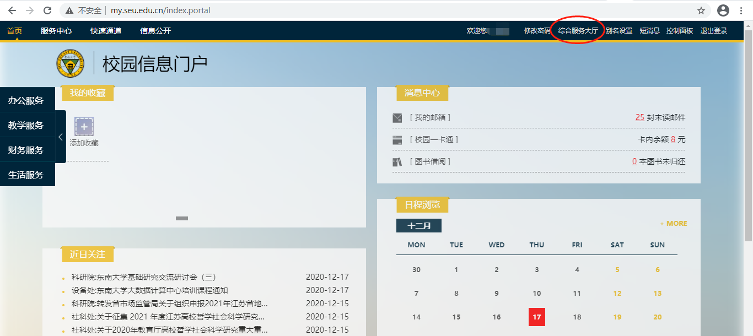

Click to login to the "Online Office Hall."

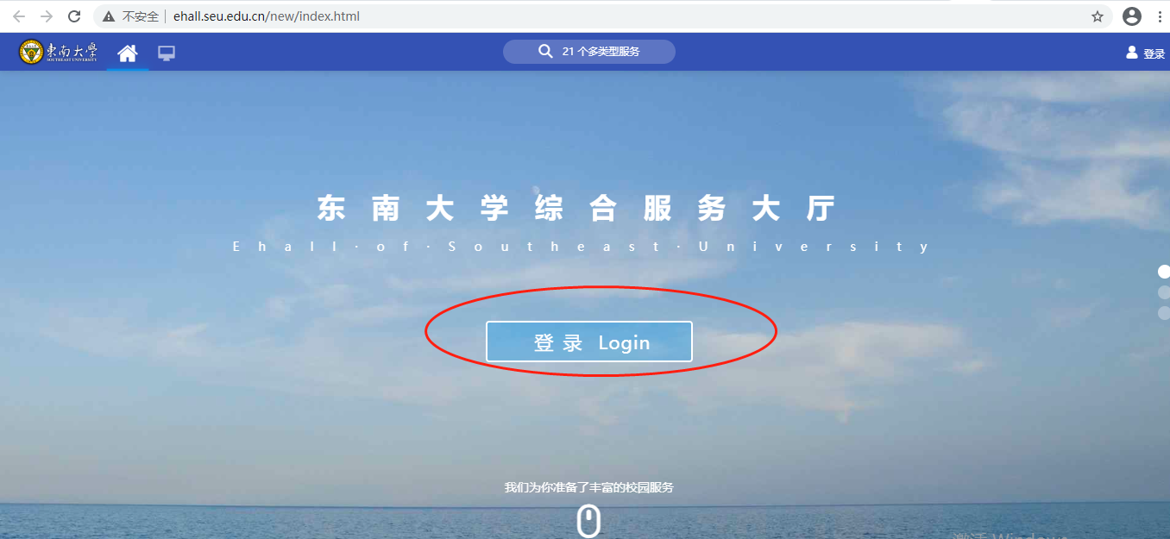

- Switch the English interface

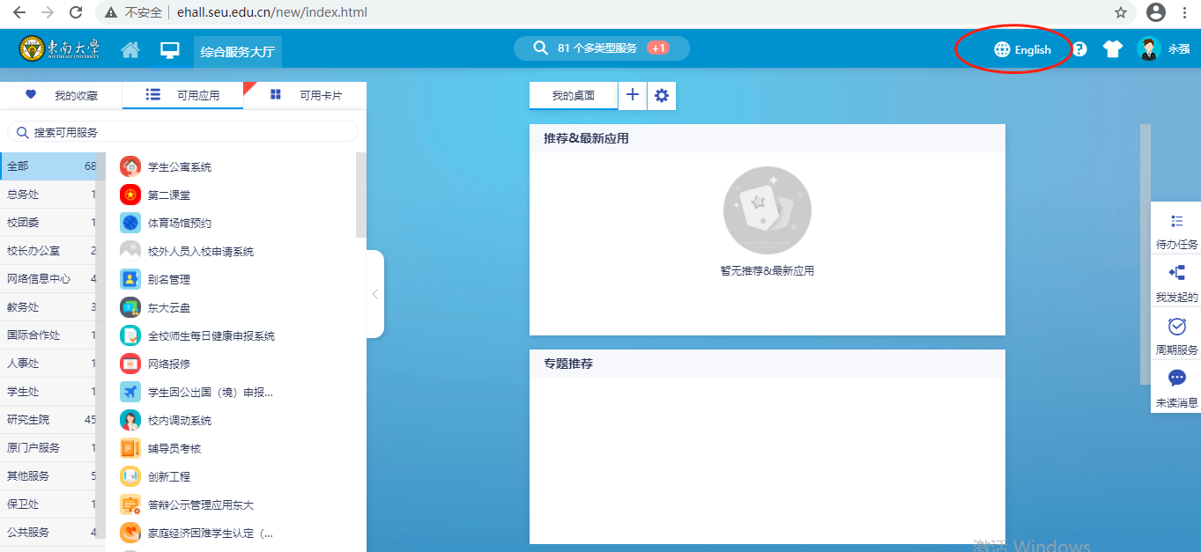
Open the Southeastern University Integrated Services Hall, point to "Available Services," search for "Registration for International Students" (support for fuzzy search), and enter the service.

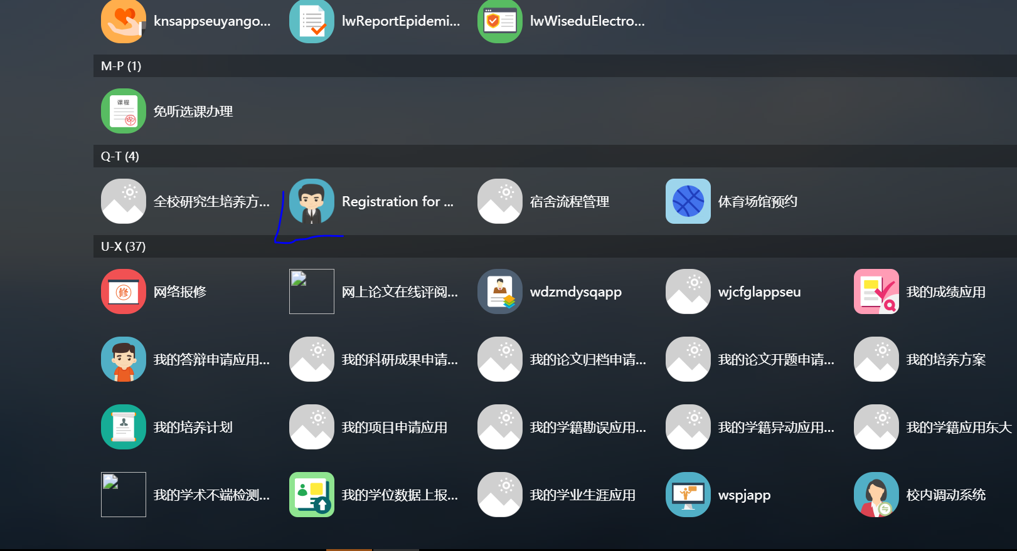

- How to register.
- Once you're in the service, find the current batch to register for your student registration and click Edit.

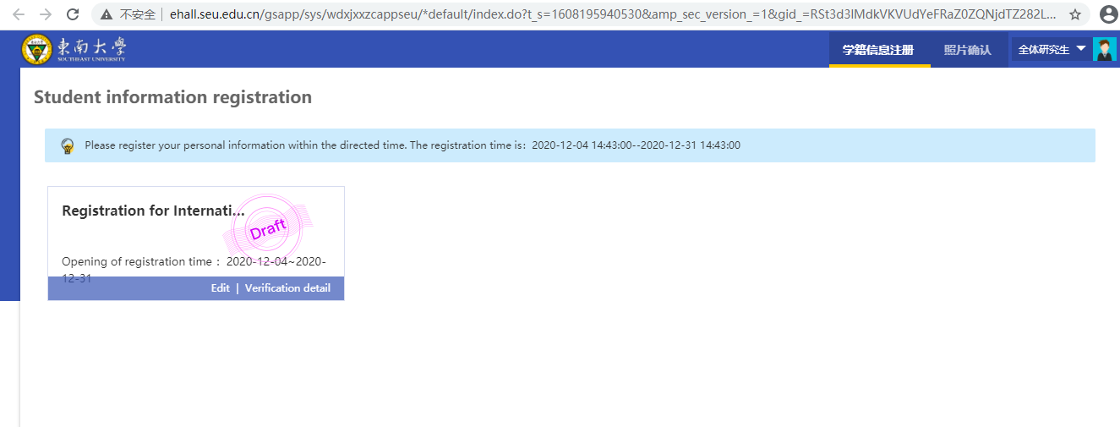

- Click "Edit" to enter, first click on the top right corner of the page "view student registration information" and read carefully.

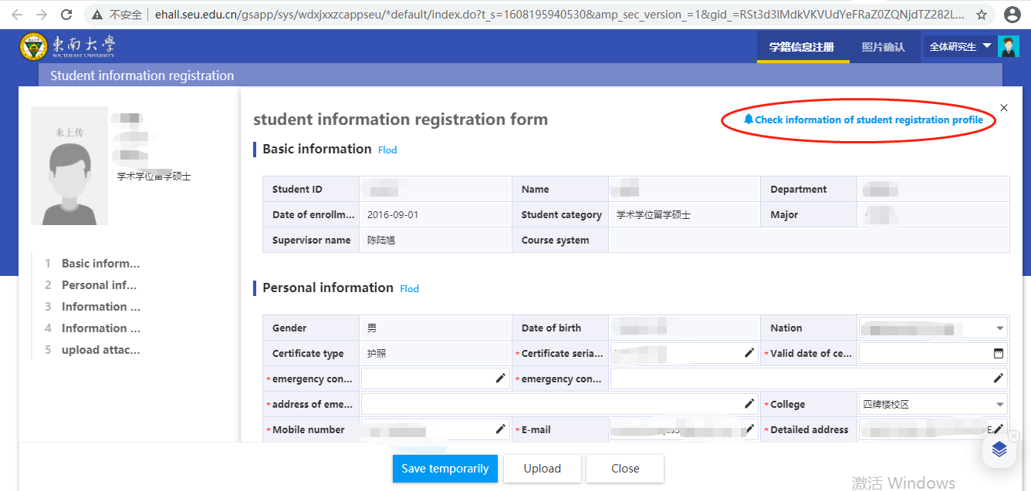

- Check that the information is correct and is required.

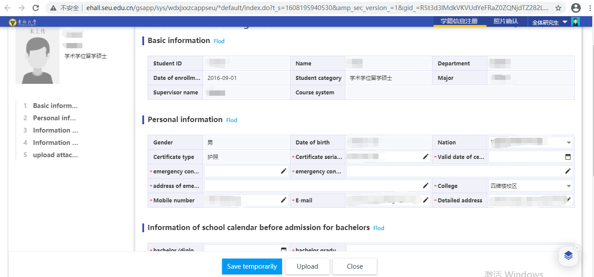

- Once you're checking the information, click Upload, you can complete your registration.

